Problem Statement
After an exam, each student has marks in several subjects. A student passes only if they score the minimum in every subject. Some students miss the pass mark by just a few marks, so the university allows grace marks under strict limits. The system must apply the pass rule and the grace policy, make sure no subject goes above the maximum marks, and give every student a final result and class.
Objectives
- Check that the marks entered are valid (0 to 100).
- Apply the subject-wise pass rule (at least 40 in every subject).
- Apply the grace-mark policy only where it is allowed.
- Make sure grace never pushes a subject above 100 or breaks a limit.
- Calculate the total, percentage and class (Distinction, First, Second, Pass Class or Fail).
Assumptions
# | Rule | Value
1 | A failed subject is raised to 40 only if it is short by | at most 5 marks
2 | Grace to pass is given only if the student failed | at most 2 subjects
3 | Maximum grace per subject (both kinds together) | 5
4 | Maximum grace per student (both kinds together) | 10
5 | Class grace: a student who has passed everything and is short of the next class by at most 5 marks may get grace to reach it | if rules 3 and 4 still hold
6 | No subject can go above | 100
Algorithm
- Read the student’s marks.
- Validate: if any mark is below 0 or above 100, the result is INVALID.
- Pass grace:
    - List the subjects with marks below 40.
    - If more than 2 are failed → FAIL.
    - If any is short by more than 5 → FAIL.
    - If the total grace needed is more than 10 → FAIL.
    - Otherwise raise each failed subject to exactly 40.
- Class grace:
- Find the total after pass grace and the next class boundary above it.
- Shortfall = boundary marks − total.
- If shortfall ≤ 5 and total grace + shortfall ≤ 10, try the lowest-scoring subject first.
- Give the grace to the first subject where the mark stays ≤ 100 and its grace stays ≤ 5.
- Final total = original + grace. Calculate the percentage and the class.
- Print the result.
Pseudocode
CONSTANTS: MAX=100, PASS=40, PASS_GRACE_LIMIT=5, MAX_FAILED=2,
MAX_TOTAL_GRACE=10, MAX_SUBJECT_GRACE=5, CLASS_GRACE_LIMIT=5

FUNCTION give_pass_grace(marks):
failed = subjects with mark < PASS
IF count(failed) > MAX_FAILED RETURN None (fail)
FOR each failed subject:
need = PASS - mark
IF need > PASS_GRACE_LIMIT RETURN None
grace[subject] = need
IF sum(grace) > MAX_TOTAL_GRACE RETURN None
RETURN grace

FUNCTION give_class_grace(marks, grace):
total = sum(marks) + sum(grace)
boundary = next class boundary above total
IF no boundary RETURN grace (already Distinction)
shortfall = boundary - total
IF shortfall > CLASS_GRACE_LIMIT RETURN grace
IF sum(grace) + shortfall > MAX_TOTAL_GRACE RETURN grace
FOR each subject from lowest marks to highest:
IF mark + grace + shortfall <= MAX AND grace + shortfall <= MAX_SUBJECT_GRACE:
grace[subject] += shortfall
RETURN grace
RETURN grace

MAIN:
FOR each student:
IF marks invalid: PRINT INVALID; CONTINUE
grace = give_pass_grace(marks)
IF grace is None: PRINT FAIL; CONTINUE
grace = give_class_grace(marks, grace)
final_total = sum(marks) + sum(grace)
percent = final_total * 100 / (MAX * number_of_subjects)
PRINT result and class(percent)
Test Cases
# | Student | Marks | Expected result | What it tests
1 | Priya | 80, 85, 78, 90, 72 | PASS, 405, Distinction, no grace | Normal pass
2 | Suma | 36, 64, 64, 64, 65 | Grace 7, 300, First Class | Pass grace (+4) then class grace (+3) given to a different subject
3 | Tarun | 38, 39, 60, 70, 80 | Grace 3, 290, Second Class | Two failed subjects, both graced
4 | Uma | 35, 35, 35, 70, 70 | FAIL | Three failures: no grace
5 | Vikram | 30, 80, 80, 80, 80 | FAIL | Short by 10 (more than 5)
6 | Wasim | 100, 100, 70, 60, 43 | Grace 2, 375 (75%), Distinction | Class grace, exact boundary
7 | Meera | 36, 36, 72, 72, 73 | Grace 8, 297, Second Class | Total grace limit (8 + 3 > 10) blocks the upgrade
8 | Yash | 100 in all five | PASS, 500, Distinction | Nothing goes above 100
9 | Arjun | 105, 70, 70, 70, 70 | INVALID | Mark above maximum
Output
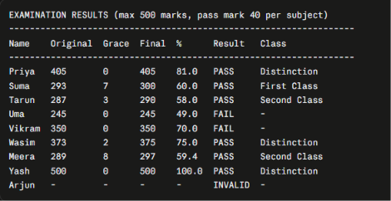

Flowchart
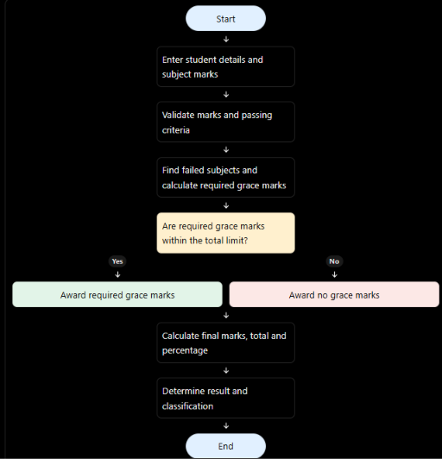
Conclusion
The program follows a fixed order: validate the marks, give pass grace, give class grace, then classify. Every rule is a constant at the top of the file, so no student can receive more grace than the policy allows and no subject can go above 100. Because the original marks, grace and final total are shown side by side, every result can be checked by hand. To change the policy (for example a different pass mark or grace limit), you only need to edit the constants.

